Lab3_2

1-=>j

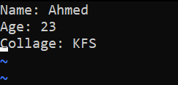

2-=>k

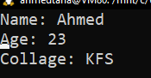

3-=>/Age

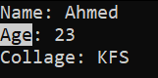

4-=>:5

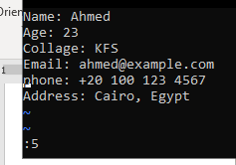

5-:=>dd inline 5

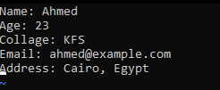

6-=> (A)

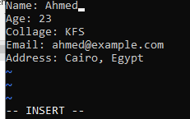

Lab 4

1-

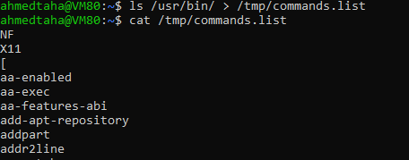

2-

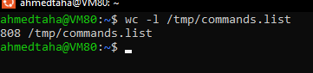

3-

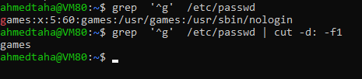

6_1-

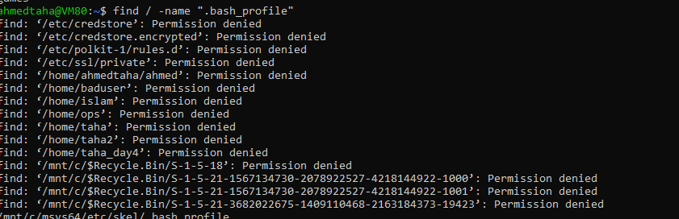

7-

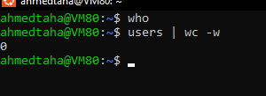

8-

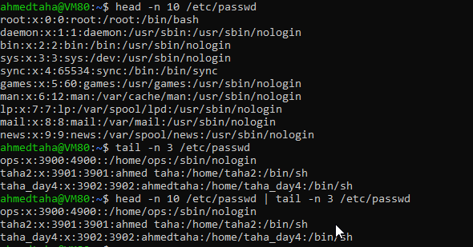

9-

1)

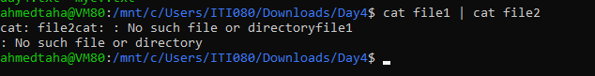

2)=> rm need files names for delete

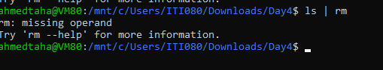

3)

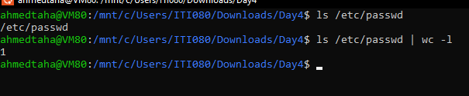

10-



11-ctrl+c

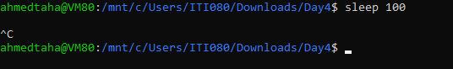

12-

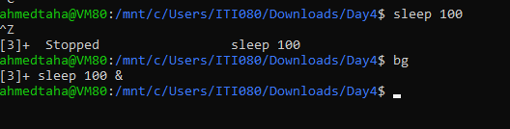

13-

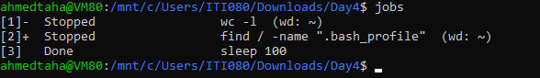

14-

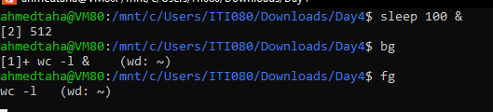

15-

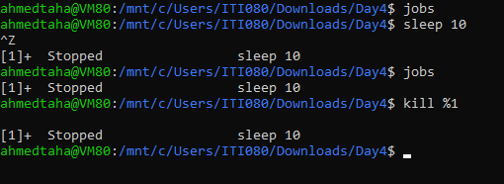

16-

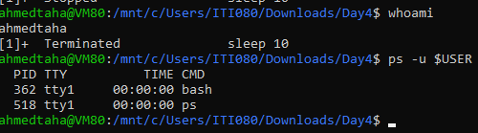

17-

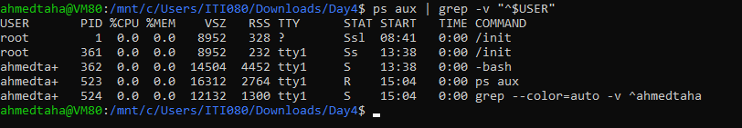

18-

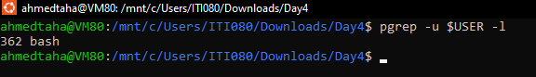

19-pkill -u $USER

